Computational drug repurposing pipeline targeting MMP-2 (Matrix Metalloproteinase-2), a key enzyme in cancer metastasis.
project workflow (work layout)
Protein Selection & Retrieval
- Target: MMP-2 (UniProt ID: P08253, PDB ID: 7XJO)
- Reason: Catalytic domain, high resolution (2.0 Å), suitable for small-molecule docking
Protein Preparation
- Removed water, ligands, ions, chain B (Discovery Studio) → kept single chain A
- Refined with GalaxyRefine (Model 5 selected)
- Validation: ERRAT ↑ 78 → 95, Ramachandran 95.6% favored
Physicochemical & Secondary Structure Analysis
- ProtParam (stability, pI, solubility)
- PSIPRED (helix, sheet, coil distribution)
Ligand Selection & Preparation
- Cephalosporins retrieved from PubChem (IDs: Cefoperazone, Ceftizoxime, Ceftazidime, etc.)
- ADME analysis with SwissADME
- Converted SDF → PDB → PDBQT (OpenBabel + ADT)
Molecular Docking (AutoDock Vina)
- Defined grid box using active site of 7XJO
- Docking performed (single + batch runs)
- Top binding affinities:
  - Cefoperazone: –7.061 kcal/mol
  - Ceftizoxime: –6.996 kcal/mol
  - Ceftazidime: –6.691 kcal/mol
Post-docking Analysis
- Complex formed only with Cefoperazone (ligand.pdb +Protein.pdb in PyMol)
- Analyzed interactions via PLIP (H-bonds, salt bridges, π–π stacking)
- 2D Diagram
- Visualized complex in PyMOL – 3D visualization
Molecular Dynamics Simulation
- Performed with iMODS
- Confirmed stability of MMP-2–Cefoperazone complex

UniProt ID -- P08253
PDB ID -- 7XJO
FASTA Sequence Physiochemical Properties (Server = ExPASy ProtParam)

Sr. no. | PDB IDs | Name | Experimental method | Resolution | Structure Validation- ERRET (Overall Quality Factor)
1. | 1CK7 | gelatinase A (full-length) | X ray | 2.80 Å | 68.3168
2. | 1EAK | Catalytic domain of prommp-2 E404Q mutant | X ray | 2.66 Å | 79.650
3. | 1GEN | C-terminal domain of gelatinase A | X ray | 2.15 Å | 85.864
4. | 1GXD | proMMP-2/TIMP-2 complex | X ray | 3.10 Å | 59.308
5. | 1QIB | Crystal structure of gelatinase A catalytic domain | X ray | 2.80 Å | 88.571
6. | 1RTG | C-terminal domain (haemopexin-like domain) of human matrix metalloproteinase-2 | X ray | 2.60 Å | 86.772
7. | 3AYU | Crystal structure of MMP-2 active site mutant in complex with APP-drived decapeptide inhibitor | X ray | 2.00 Å | 79.618
8. | 7XGJ | Crystal structure of human MMP-2 catalytic domain in complex with inhibitor | X ray | 2.80 Å | 78.7234
9. | 7XJO | Crystal structure of human MMP-2 catalytic domain in complex with inhibitor | X ray | 2.00 Å | 79.739
10. | 8H78 | Crystal structure of human MMP-2 catalytic domain in complex with inhibitor | X ray | 2.40 Å | 74.267

Recommendation (one-line):
Use 7XJO for small molecule docking (primary choice). Use 3AYU only if you plan to dock/ study peptide-type inhibitors or substrate interactions. Use the other entries only if you have a specific reason (domain study, full-length behavior, or to build an ensemble).
Why 7XJO (primary pick)
- Resolution = 2.00 Å — excellent atomic detail for docking.
- Co-crystallized small-molecule inhibitor present — ideal for redocking validation (gives exact ligand instance to reproduce).
- Catalytic domain (binding pocket present) and Zn ion modeled — essential for MMP chemistry/coordination.
- ERRAT ~79.7 — acceptable for a practical docking project (you’ll still run further validation and optional refinement).
- Recent medicinal-chemistry context (useful metadata / SAR).
Why not some other entries for small-molecule docking
- 3AYU — also 2.00 Å but the ligand is an APP-derived decapeptide and the structure is an active-site mutant. Great for peptide/mechanistic work, not ideal as a template for small-molecule redocking.
- 1GEN / 1RTG / 1QIB — have good ERRATs (1GEN/1RTG high) but either represent C-terminal / non-catalytic domains or lower resolution for catalytic work. If your focus is catalytic site small-molecule design, these are secondary.
- Higher ERRAT but lower resolution (e.g., 1QIB) — ERRAT alone doesn’t compensate for poorer resolution when precise ligand geometry is needed.
- Entries with low ERRAT or >3 Å (e.g., 1GXD at 3.10 Å) — avoid for detailed docking.

  - Protein Sequence and Structure Retrieval
The protein sequence of MMP-2 was retrieved from database Uniprot with Uniprot ID: P08253 in FASTA format.
>sp|P08253|MMP2_HUMAN 72 kDa type IV collagenase OS=Homo sapiens OX=9606 GN=MMP2 PE=1 SV=2
MEALMARGALTGPLRALCLLGCLLSHAAAAPSPIIKFPGDVAPKTDKELAVQYLNTFYGC
PKESCNLFVLKDTLKKMQKFFGLPQTGDLDQNTIETMRKPRCGNPDVANYNFFPRKPKWD
KNQITYRIIGYTPDLDPETVDDAFARAFQVWSDVTPLRFSRIHDGEADIMINFGRWEHGD
GYPFDGKDGLLAHAFAPGTGVGGDSHFDDDELWTLGEGQVVRVKYGNADGEYCKFPFLFN
GKEYNSCTDTGRSDGFLWCSTTYNFEKDGKYGFCPHEALFTMGGNAEGQPCKFPFRFQGT
SYDSCTTEGRTDGYRWCGTTEDYDRDKKYGFCPETAMSTVGGNSEGAPCVFPFTFLGNKY
ESCTSAGRSDGKMWCATTANYDDDRKWGFCPDQGYSLFLVAAHEFGHAMGLEHSQDPGAL
MAPIYTYTKNFRLSQDDIKGIQELYGASPDIDLGTGPTPTLGPVTPEICKQDIVFDGIAQ
IRGEIFFFKDRFIWRTVTPRDKPMGPLLVATFWPELPEKIDAVYEAPQEEKAVFFAGNEY
WIYSASTLERGYPKPLTSLGLPPDVQRVDAAFNWSKNKKTYIFAGDKFWRYNEVKKKMDP
GFPKLIADAWNAIPDNLDAVVDLQGGGHSYFFKGAYYLKLENQSLKSVKFGSIKSDWLGC

The 3D Structure of Crystal structure of human MMP-2 catalytic domain in complex with inhibitor was obtained from Protein Data Bank (PDB) with PDB ID: 7XJO which was used for further analysis and was visualized using discovery studio as shown in Figure 1 to examine its overall structure.
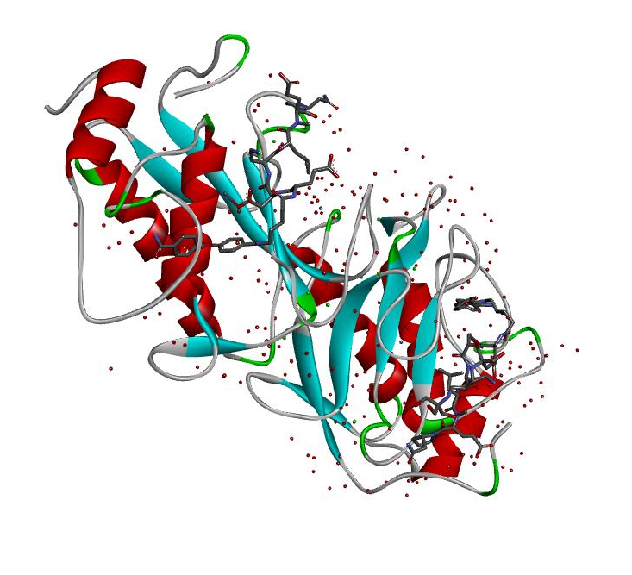
Figure 1: The 3D Structure of Crystal structure of human MMP-2 catalytic domain in complex with inhibitor - 7XJO
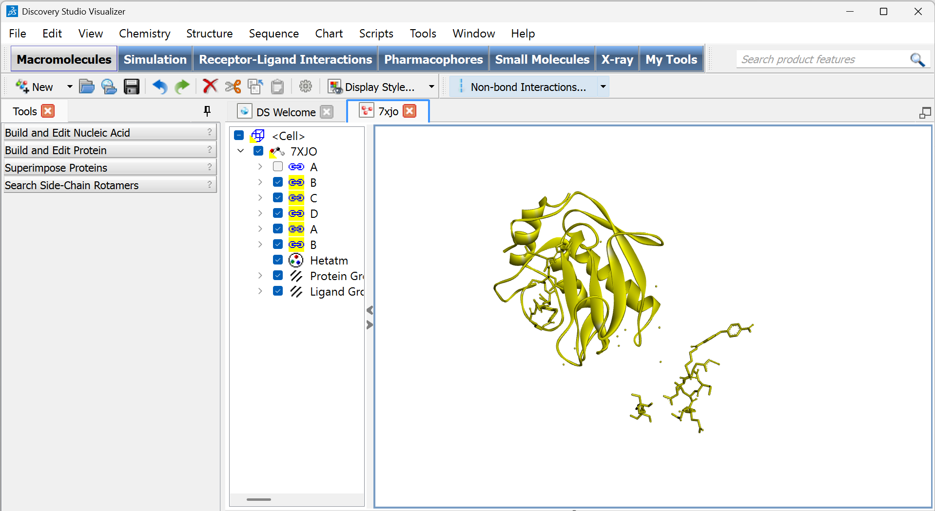
Figure 2: Removed Water Molecules, Hided the Chain A and Selected all remaining Chain B,C,D -- A,B (I don't know what were these 2), Ligands, Hetatm and Deleted them in Discovery Studio, juts kept the single chain A and saved as .pdb file for Protein Refinement through Galaxy refine.
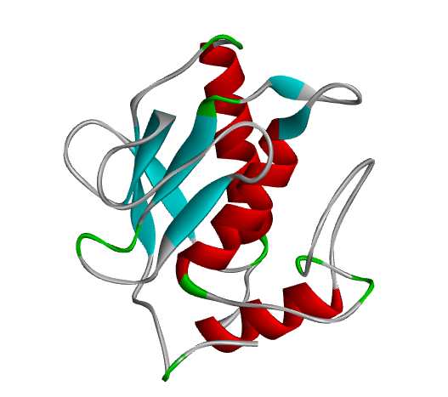
Figure 3: MMP-2_Single Chain A_7xjo

Analysis of physiochemical properties
To analyze physiochemical properties of MMP-2, the Expasy ProtParam tool was used. This analysis provides key insights into the stability, solubility and characteristics of protein. It shows that MMP-2 protein contains 660 total amino acid. Physicochemical properties of the target protein were evaluated using the ProtParam tool. The instability index was calculated as 27.46, which is below the threshold value of 40, indicating that the protein is predicted to be stable in vitro and less prone to rapid degradation under experimental conditions (Guruprasad et al., 1990). The theoretical isoelectric point (pI) was found to be 5.26, classifying the protein as acidic in nature. At physiological pH (~7.4), this would result in a net negative charge on the protein surface, potentially enhancing aqueous solubility and favoring electrostatic interactions with positively charged molecules or metal ions, while possibly repelling other negatively charged species. The aliphatic index of 61.09 reflects moderate thermostability, while the negative GRAVY value (-0.446) suggests a hydrophilic nature and good aqueous solubility. The high extinction coefficient (128,325 M⁻¹ cm⁻¹) indicates strong UV absorbance at 280 nm, facilitating protein quantification in solution. Additionally, the estimated half-life of 30 hours in mammalian reticulocytes suggests that MMP-2 possesses moderate stability in a cellular environment. Collectively, these properties indicate that the protein is likely to remain stable and soluble under physiological conditions as shown in Table 2.
Table 2: The physiochemical properties of MMP-2 protein obtained through Expasy ProtParam
S.no | Instability index | Gravy Value | Pi value | Extinction coefficient | Half life
1 | 27.46 | -0.446 | 5.26 | 127200 | 30 hours

Secondary structure prediction
The secondary structure of MMP-2 protein was predicted using PSIPRED. Figure 4 shows the distribution of alpha helix and beta sheet in MMP-2 protein, pink region shows 101 residues of alpha helix, and 102 residues of yellow region indicate beta sheets, and the rest of the grey part are in loop and coil region. Overall results indicate the uniform distribution of alpha and beta helix make them well-defined functional protein.
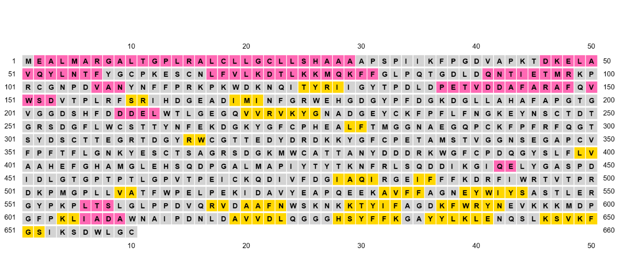
Figure 4: Secondary structure obtained through PSIPRED
Name: sp|P08253|MMP2_HUMAN

Analysis of protein quality
The ERRAT and PROCHECK tool was used to evaluate the overall quality of MMP-2 protein providing an overall quality factor of 78.289 (Figure 5). The result indicates that the overall structure is acceptable for docking but improvement in certain regions is required, as ERRAT score greater than 90 is considered as good score.

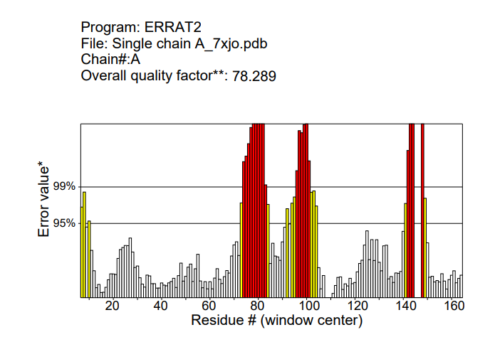
Figure 5: Results obtained through ERRAT. The Y axis represents the error rate, and the X axis represents the sequence position. Red bars indicate residues where error exceed 99% confidence and yellow bar indicates 95% confidence and white and grey bar represent.

PROCHECK Results
Out of 8 evaluations
- Errors: 2
- Warning: 4
- Pass: 2
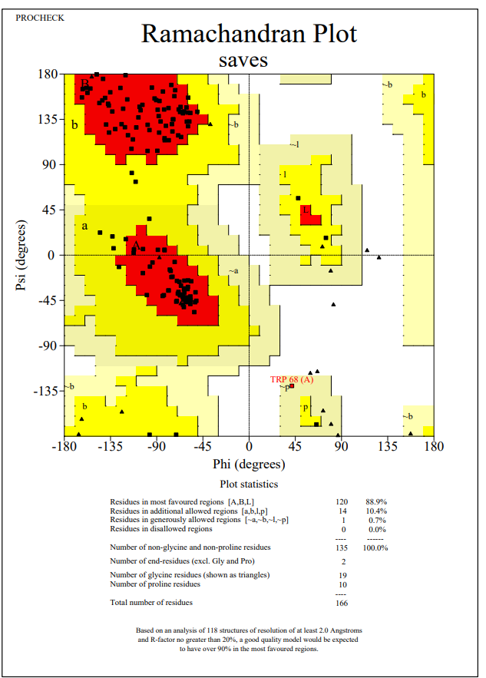

Refinement of the protein
To increase protein quality, Galaxy Refine tool was used. It enhances backbone flexibility, optimizes sidechain and minimizes steric clashes and Rama favored value. MODEL 5 was used for subsequent docking after local inspection confirmed no steric clashes or rotamer outliers in the predicted binding site. Post-refinement validation metrics for MODEL 5 confirmed that the protein has strong geometry leading to more reliable and accurate structure for molecular docking as shown in Table 3.
Table 3: Galaxy Refine Index of MMP-2_Single Chain A_7XJO
Model | GDT-HA | RMSD | Mol Probity | Clash score | Poorrotamers | Rama favored
MODEL 5 | 0.9895 | 0.267 | 1.341 | 6.2 | 0.0 | 98.8

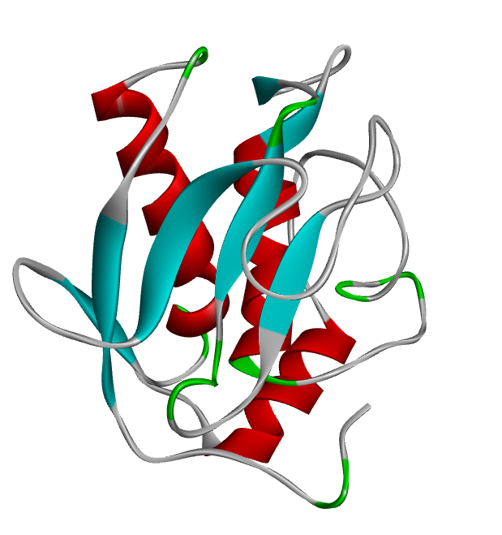
Figure 6: Module 5 - MMP-2-Single Chain A -7XJO

Modules - MMP-2 protein Single Chain_7xjo
Structure Information – These were 5 Modules from Galaxy Refine
Model | GDT-HA | RMSD | MolProbity | Clash score | Poorrotamers | Rama favored
Initial | 1.0000 | 0.000 | 1.961 | 5.5 | 3.0 | 95.7
MODEL 1 | 0.9849 | 0.307 | 1.405 | 7.4 | 0.8 | 99.4
MODEL 2 | 0.9895 | 0.272 | 1.522 | 7.0 | 1.5 | 99.4
MODEL 3 | 0.9819 | 0.289 | 1.363 | 6.6 | 0.8 | 99.4
MODEL 4 | 0.9910 | 0.266 | 1.501 | 6.6 | 1.5 | 98.8
MODEL 5 | 0.9895 | 0.267 | 1.341 | 6.2 | 0.0 | 98.8

Post-Refinement Validation
Resubmitted the refined model to ERRAT/PROCHECK
After refining the structure of MMP-2_Single Chain A_7XJO, the ERRAT score was checked again, increasing the quality factor from 78.289 to 94.8718, indicating the improvement in structural quality. The result shows that the refined structure is higher quality than initial model shown in Figure.
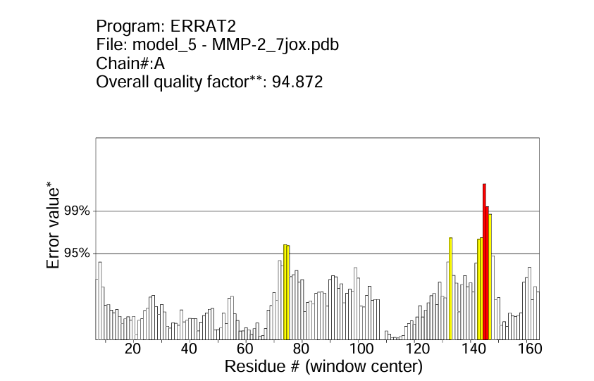
Ramachandran plot
Ramachandran plot was constructed to assess the allowed regions of phi and psi dihedral angles in protein backbone structure. The analysis revealed that 95.6% of protein residues were in the most favorable region, while 1.5% lie in generously allowed region, and 0% residue lies in disallowed region indicating excellent structural geometry (Figure).
PROCHECK Complete
Out of 8 evaluations
- Errors: 2
- Warning: 1
- Pass: 5
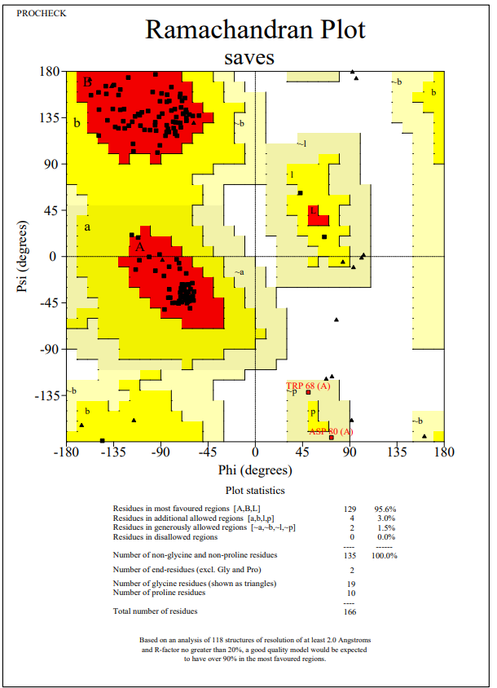

Ligand Selection
Sr. no. | Rule | Pass Criteria | Why
1. | Molecular Weight (MW) | 150–500 g/mol | Too large → poor absorption; too small → non-specific binding.
2. | LogP (lipophilicity) | 0–5 | Controls membrane permeability vs solubility. Very high → insoluble/toxic; very low → poor absorption.
3. | Topological Polar Surface Area (TPSA) | 20–130 Å² | Lower → good permeability; >140 Å² → poor oral absorption.
4. | GI Absorption | High | Indicates good intestinal uptake.
5. | Bioavailability Score | ≥ 0.55 | Higher score → greater chance of good systemic exposure.
6. | P-glycoprotein (P-gp) Substrate | Preferably No | If substrate, drug may be effluxed → reduced efficacy.
7. | CYP450 Inhibition | Avoid inhibition of key enzymes (CYP3A4, CYP2D6, etc.) | Reduces drug-drug interactions & toxicity.

Table: Name of Cephalosporins with PubChem IDs and Validation remarks through SwissADME webserver and selected as Ligands .
Sr. no. | Ligand Name | PubChem ID | Validation of Drug-Likeness Properties | Interactions Energies (Kcal/mol)
1 | Cefixime  Severity Grade – 4 | 5362065 | Lipinski: Yes; 1 violation: NorO>10  Primary Hazards: Irritant, Health Hazard  Molecular weight: 453.45 g/mol  LogP (lipophilicity): -0.39  TPSA: 238.05 Å²  GI Absorption (predicted): Low  Bioavailability Score: 0.11  P-gp: No  CYP: No | -6.353
2 | Cefditoren  Severity Grade – 2 | 9870843 | Lipinski: ; violation  Molecular weight: 506.58 g/mol  LogP (lipophilicity): NM  Topological Polar Surface Area (TPSA): 241.88 Å²  GI Absorption (predicted): NM  Bioavailability Score: NM  P-gp: NM  CYP: NM | -6.355
3 | Ceftibuten  Severity Grade – 3 | 5282242 | Lipinski: Yes; 0 violation  Primary Hazards: Irritant, Health Hazard  Molecular weight: 410.42 g/mol  LogP (lipophilicity): -0.16  TPSA: 216.46 Å²  GI Absorption (predicted): Low  Bioavailability Score: 0.11  P-gp: No  CYP: No | -6.584
4 | Cefoperazone  Severity Grade – 3 | 44187 | Lipinski: No; 2 violations: MW>500, NorO>10  Primary Hazards: Health Hazard  Molecular weight: 645.67 g/mol  LogP (lipophilicity): -0.98  TPSA: 270.86 Å²  GI Absorption (predicted): Low  Bioavailability Score: 0.11  P-gp: Yes  CYP: No | -7.061
5 | Ceftazidime  Less-DILI-Concern  Severity Grade – 3 | 5481173 | Lipinski: No; 2 violations: MW>500, NorO>10  Primary Hazards: Acute toxic, Irritant, Health Hazard  Molecular weight: 546.58 g/mol  LogP (lipophilicity): -1.39  TPSA: 244.76 Å²  GI Absorption (predicted): Low  Bioavailability Score: 0.11  P-gp: No  CYP: No | -6.691
6 | Cefpodoxime  Ambiguous DILI-concern  Severity Grade – 3 | 6335986 | Lipinski: Yes; 1 violation: NorO>10  Primary Hazards: Health Hazard  Molecular weight: 427.46 g/mol  LogP (lipophilicity): -0.32  TPSA: 209.98 Å²  GI Absorption (predicted): Low  Bioavailability Score: 0.11  P-gp: No  CYP: No | -5.868
7 | Cefotaxime  Less-DILI-Concern  Severity Grade – 5 | 5742673 | Lipinski: Yes; 1 violation: NorO>10  Primary Hazards: Irritant, Health Hazard  Molecular weight: 455.47 g/mol  LogP (lipophilicity): -0.27  TPSA: 227.05 Å²  GI Absorption (predicted): Low  Bioavailability Score: 0.11  P-gp: No  CYP: No | -6.303
8 | Ceftizoxime  Ambiguous DILI-concern  Severity Grade – 4 | 6533629 | Lipinski: Yes; 0 violation  Primary Hazards: Irritant, Health Hazard  Molecular weight: 383.40 g/mol  LogP (lipophilicity): -0.14  TPSA: 200.75 Å²  GI Absorption (predicted): Low  Bioavailability Score: 0.11  P-gp: No  CYP: No | -6.996

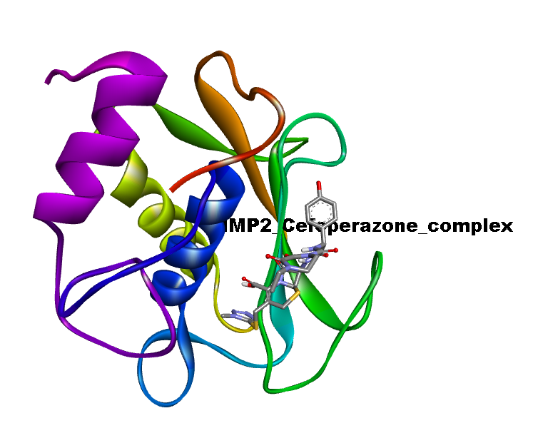
Figure: Complex of MMP2_Cefoperazone_complex formed in PyMol

Formed a complex of protein and ligand in PyMol an save it in pdb and uploaded on PLIP webserver site. And iMOD for MD simulation.
https://plip-tool.biotec.tu-dresden.de/plip-web/plip/result/fdbcdf94-4ea9-4af1-8533-cb59e4ab1cb2
🧾 Table: MMP-2 amino acids involved in different types of interactions with Cefoperazone
Interaction Type | Amino Acid(s) (Chain A) | Details
Hydrogen Bonds | LEU83, ALA84, ALA86, ALA88 | Distances 2.13–2.36 Å; strong donor–acceptor geometry
π-Stacking | PHE87 | T-shaped stacking with ligand aromatic ring
Salt Bridges | HIS121, HIS125, HIS131 | With ligand carboxylate group, distances 3.96–5.31 Å

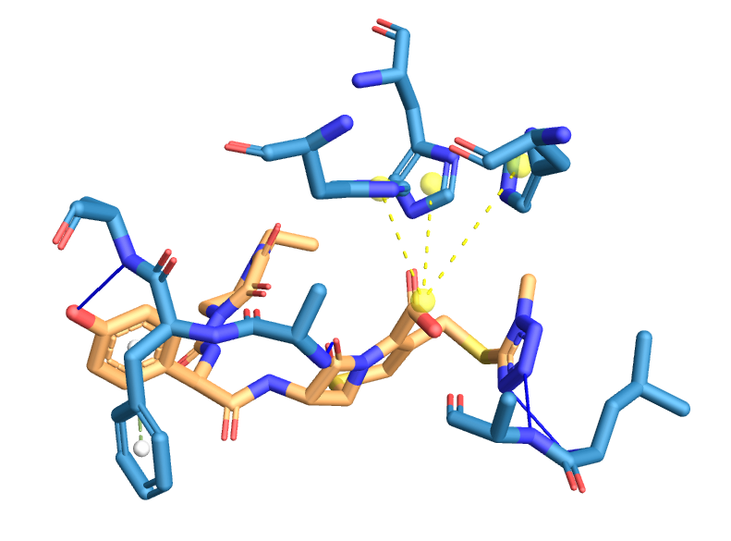
Figure: 2D ligand interaction diagrams – PLIP

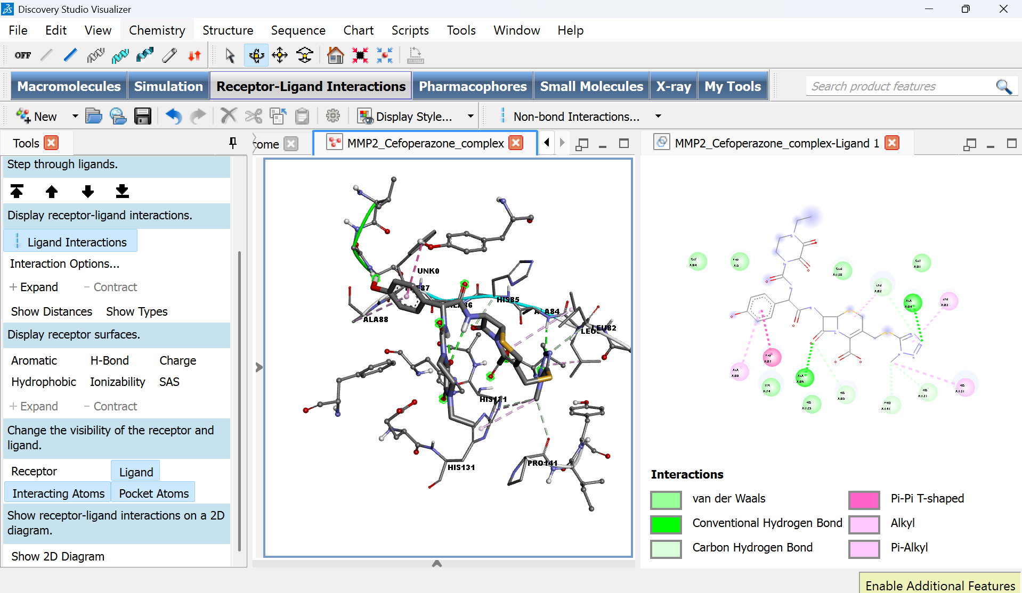

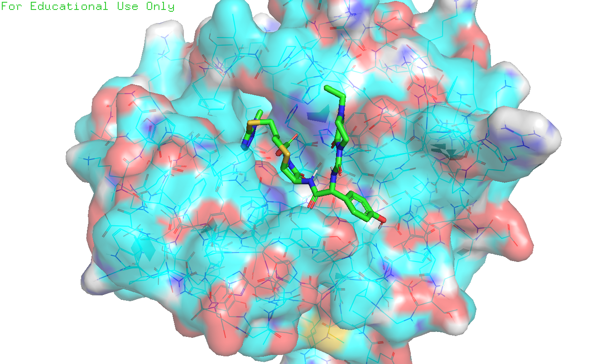

MD Simulation
Job ID "iMODS results" ID 0700002106757(CG=CA ENM=edNMA Deform=ON)
https://imods.iqf.csic.es/Results/job0700002106757/index2.html?USE=HTML5

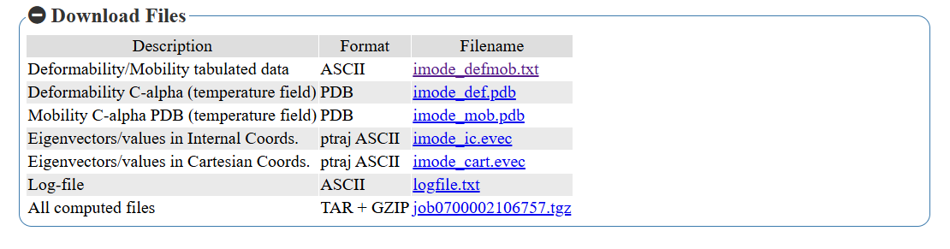
Results (Normal Mode Analysis of MMP2–Cefoperazone complex)
Normal Mode Analysis (NMA) was performed using iMODS to assess the dynamic stability of the MMP2–Cefoperazone complex. The deformability plot revealed localized flexible regions mainly around residues 40–60 and 100–120, suggesting the presence of loops involved in conformational adjustment. The B-factor profile of the NMA closely matched the experimental PDB data, supporting the reliability of the predicted motions. The variance plot indicated that the first 5–7 modes contribute predominantly to the overall motion, highlighting the collective nature of conformational changes. The first eigenvalue was 7.52 × 10⁻⁴, indicating a stable complex requiring minimal energy for deformation. Furthermore, the covariance map demonstrated correlated and anticorrelated motions between residues, while the elastic network revealed dense interatomic connections, both of which confirm the structural stability and effective communication within the complex.
Normal Mode Analysis (NMA) results of MMP2–Cefoperazone complex using iMODS.
Parameter | Result (from graph) | Interpretation
Deformability | Peaks observed around residues ~40–60, 100–120 | Indicates flexible loop regions, important for protein dynamics.
B-Factor (NMA vs PDB) | Similar fluctuation trends | Confirms reliability of NMA predictions compared with experimental data.
Variance (%) | First 5–7 modes contribute most | Suggests that a few collective motions dominate conformational changes.
Eigenvalue (Mode 1) | 7.52 × 10⁻⁴ | Low eigenvalue → less energy required for deformation, stable binding.
Covariance Map | Correlated motions (red), anticorrelated (blue) | Indicates communication between domains and allosteric regions.
Elastic Network | Dense gray dots across structure | Reveals strong interatomic connections and structural stability.

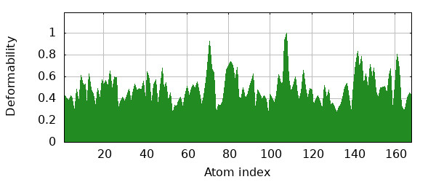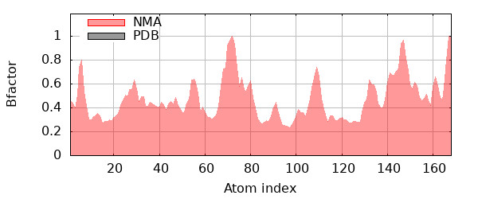
A B
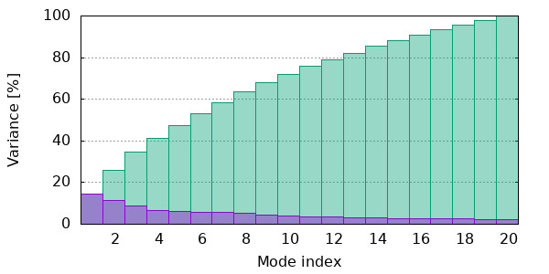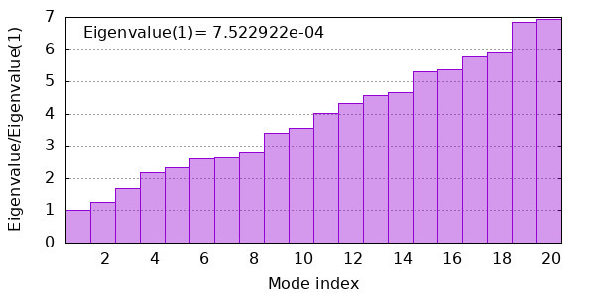
C D
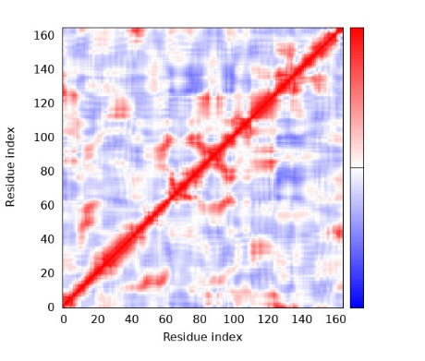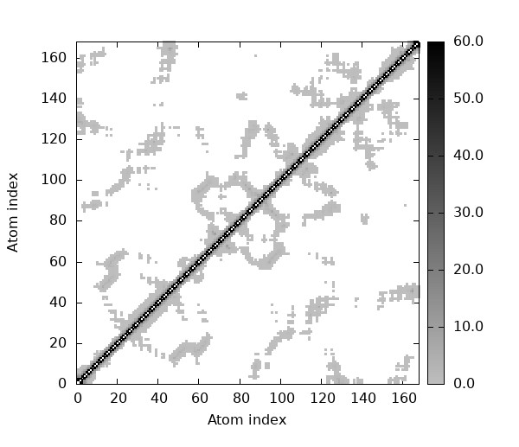
E F
Figure: (A) Deformability plot showing flexible regions (peaks at residues ~40–60, 100–120), (B) B-factor plot comparing NMA-predicted fluctuations with experimental data, (C) Variance plot indicating that the first 5–7 modes dominate the motion, (D) Covariance map showing correlated (red), uncorrelated (white), and anticorrelated (blue) motions, (E) Elastic network model displaying interatomic connections (gray dots).

NM = Not Mentioned, Toxicity – DILI (Drug Induced Liver Injury) 1. Less-DILI-Concern 2. Ambiguous DILI-concern - Severity Grade - Label Section: Adverse reactions

